TERMINOLOGY USED IN THE SONG
SCARAMoUCHE = HE IS A CHARACTER IN ITALIAN OPERA. HE IS GENERALLY CONSIDERED TO BE A CLOWN/FOOL (THEATRICAL REFERENCE)

FANDANGO = A SPANISH DANCE ACCOMPANIED BY GUITARS AND CASTINETS. MOZARTS OPERA “THE MARRIAGE OF FIGARO” HAS A FANDANGO IN IT (OPERATIC REFERENCE)

GALILEO = AN ITALIAN PHYSIcIST/ MATHEMATICIAN/ AND ASTRONOMER FROM THE 16TH CENTURY (HISTORICAL REFERENCE)

FIGARO = HE IS A SERVANT CHARACTER FROM MOZARTS OPERA (OPERATIC REFERENCE)

BISMILLAH = THIS IS AN ISLAMIC PRAYER MEANING “IN THE NAME OF ALLAH” (it’s the SAME AS SAYING “IN THE NAME OF GOD”) THIS IS A RELIGIOUS REFERENCE
BIELZEBUB = THE DEVIL SECOND TO SATAN-THE ARCHANGEL EXPELLED FROM HEAVEN. THIS IS A LITERARY REFERENCE TO A POEM CALLED “PARADISE LOST”

STRUCTURE OF BOHEMIAN RHAPSODY

INTRO  BARS 1-5  SOFT ROCK | MAIN SONG  VERSE 1  BARS  17-34  BALLAD  STYLE | VERSE 2  BARS  35-46  BALLAD  STYLE | GUITAR  INTERLUDE  BARS  47-54  HARD ROCK | OPERATIC  SECTION  BARS  55-95  OPERATIC  STYLE | GUITAR  INTERLUDE  BARS  96-99  HARD  ROCK | 2ND SONG  (VERSE)  AND RIFF  BARS  100-122  HARD ROCK | RECAP AND CODA  BARS  123-138  SOFT ROCK
B  FLAT AND  G MINOR | B FLAT AND E FLAT | B FLAT  AND E FLAT | E FLAT | A MAJOR | E FLAT | E FLAT | E FLAT  B FLAT  F

Instruments used in Bohemian Rhapsody:

Guitar, bass guitar, drum kit, vocals and piano

Introduction section bars 1 – 4
- Key signature: B flat Major
- Time signature: 4/4
- The time signature changes to 5/4 in bar 3. This allows the music to follow the rhythm of the words
- There is no instrumental introduction (compositional technique)
- 4 bars of vocal a capella singing (performance technique)
- This vocal part was multi-tracked (recording technique)
- There is overdubbing in these 4 bars (recording technique)
- There are repeated notes in the vocal line
- There is syncopation (bar starts with a rest or tied notes)

NOW USING YOUR SCORE: LETS FIND EXAMPLES OF THE FOLLOWING IN THE SCORE

Introduction to Bohemian Rhapsody
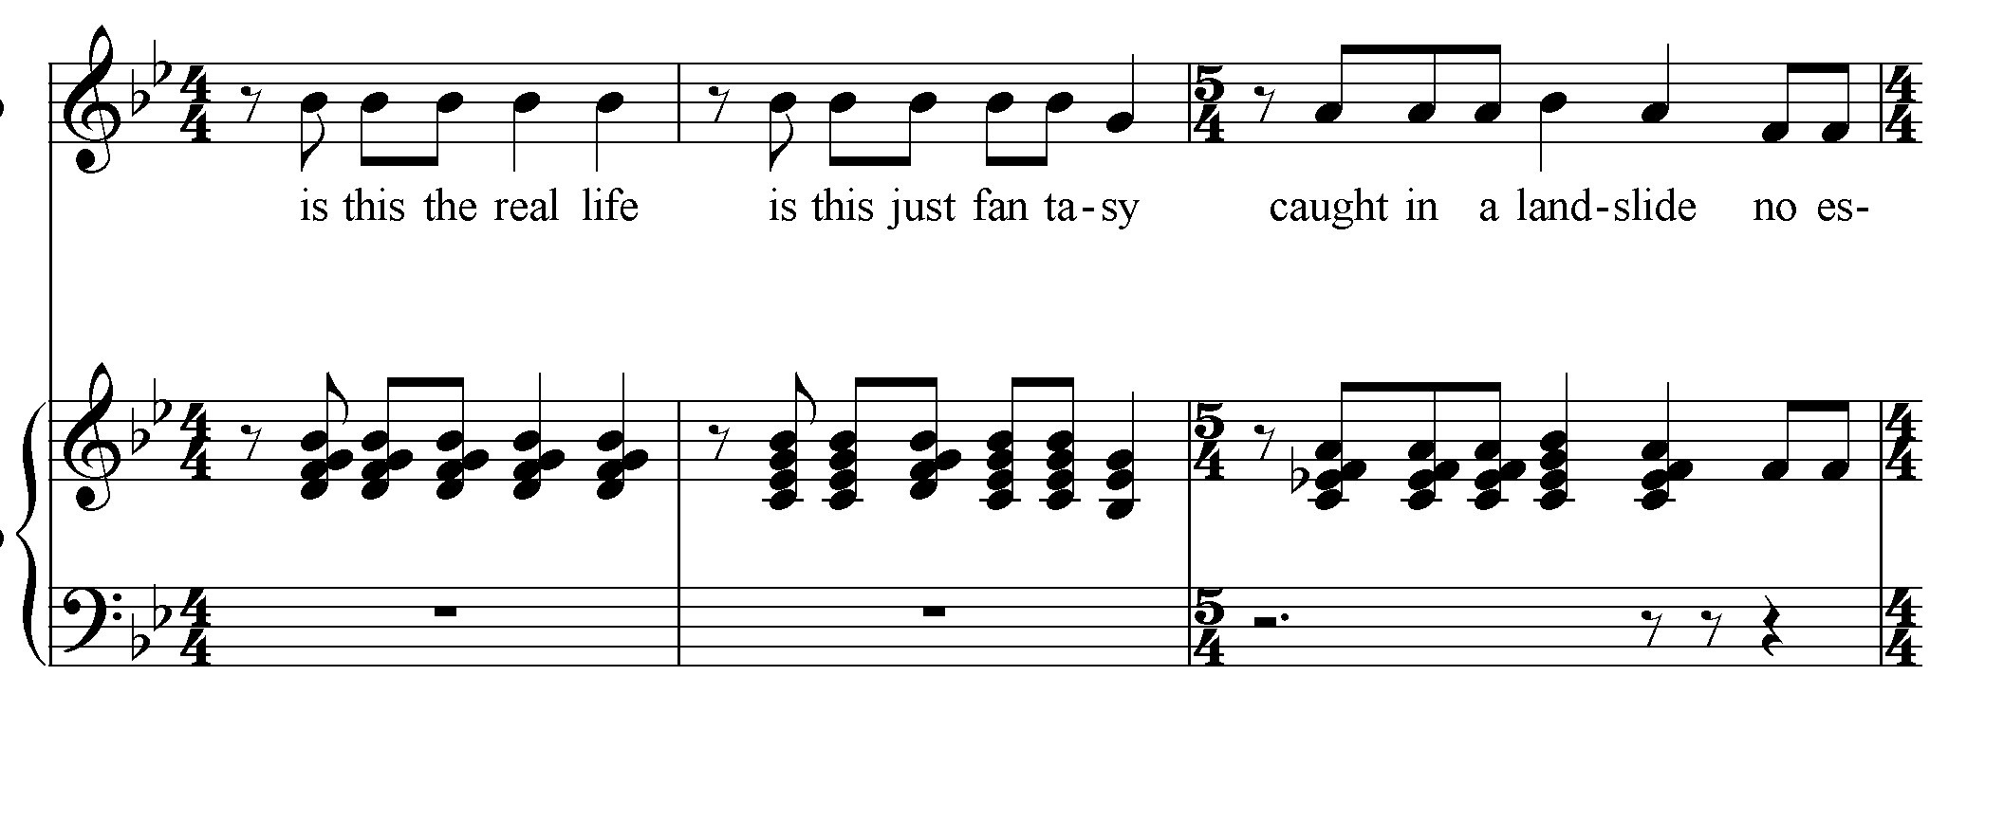
g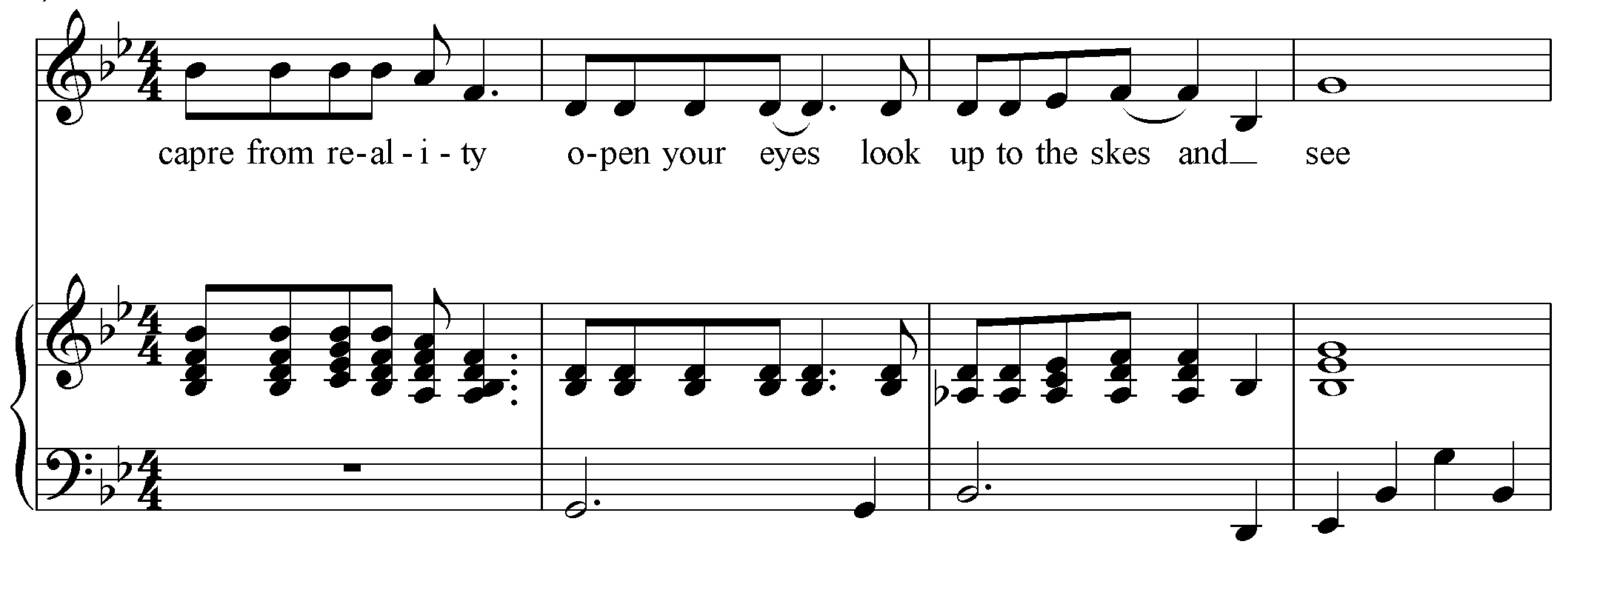
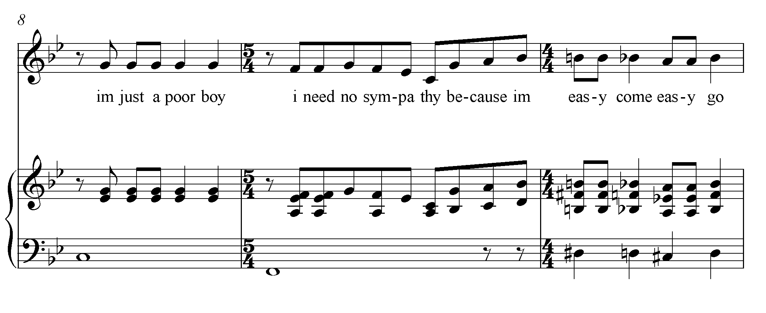
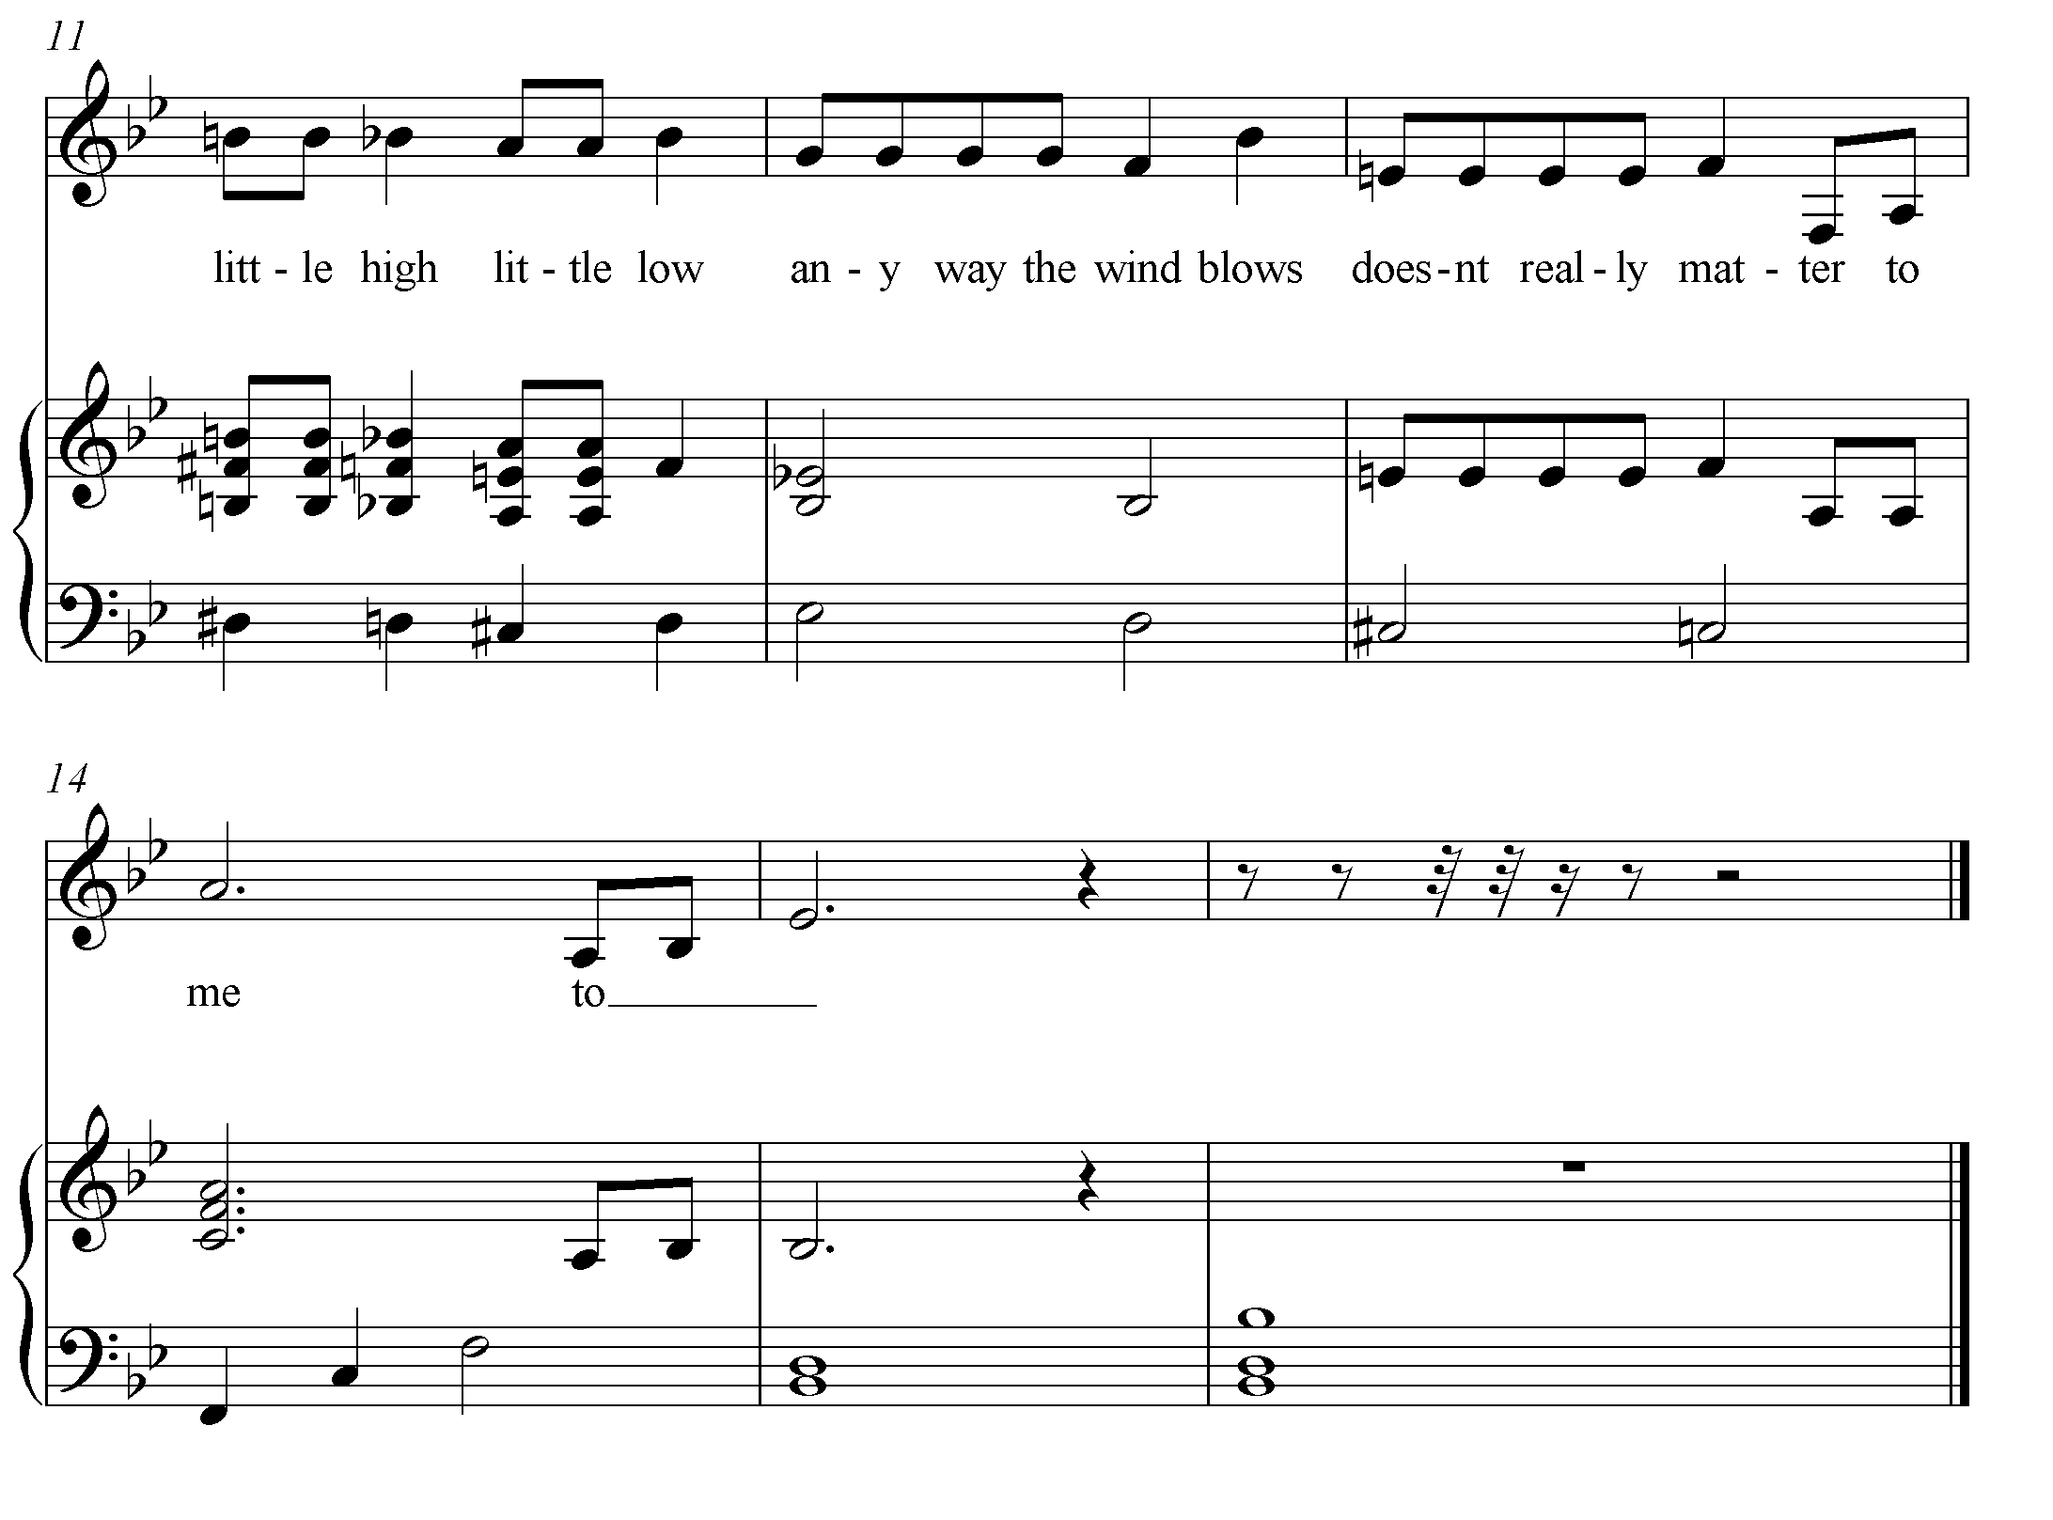

NOW FOLLOWING THE SCORE FOR THE VOCAL PART ONLY:
WRITE THE FIRST 7 BARS IN YOUR MANUSCRIPT

Bars 5 to 16 Features of the music
- Eleven bars of vocal harmony accompanied with piano and cymbals (bars 12/13) and bass guitar (bars 15)
- There are changing time signatures
- The melody contains repeated notes and syncopation
- In bar 5 the piano enters playing g minor chord (triad)
- The piano plays broken chords
- In bar 8 on the words “I’m just a poor boy” backing vocals sing a counter-melody
- In bar 10 the guitar chords chromatically fall by a semi-tone while the vocalist sings “easy come easy go”
- There is stereo panning in bar 11 on the words “little high little low” (left to right)
- There is word-painting in bar 12/13 on crash cymbals on the words “anywhere the wind blows” (called “Flanging”
“Flanging” means to record 2 separate tracks of cymbals and then put the 2 tracks back together but out-of-sync

Getting to know the score: handout page 117
- -Name the album from which this single was taken
- When was the album recorded?
- What was the origin of the title of the album?
- When was the album released?
- When was the single “Bohemian Rhapsody” released?
- Who composed this single?
- Describe briefly the instrumentation in this song?
- Comment briefly on the vocal part
- List 3 features of the song which were unusual for ha pop song of the 1970s

1.83 Introduction (bars 1-4)
1. The opening four bars are sung a capella. Explain what this means

2. What is the tonality of these four bars?

3. describe 2 musical features of this opening
(1)______________________________________________________________
(11)_____________________________________________________________

4. Listen to the 4 bars again and complete the rhythm of the melodic outline below

1.84 Introduction (bars 5-16)

1. Name the chord in bar 5__________________________________________
2. Describe the piano part from bar 5 onwards__________________________
________________________________________________________________________________________________________________________________
3. What happens at the words “I’m just a poor boy”_____________________
________________________________________________________________j________________________________________________________________
4. How does the music paint the picture of the wind blowing?_____________
________________________________________________________________
5. From the following list, select any 3 features which you hear in this excerpt. Refer to the appropriate text in each feature
- Syncopation_________________________________________________
- Chromatic movement_________________________________________
- Descending bass line__________________________________________
- Panning____________________________________________________
- Glissando___________________________________________________

Main song verse 1 bars 17 – 34 (piano/bass/vocals/drums)
- This is in the style of a Ballad
- jKey = B flat major moving towards E flat major
- There is A 2 bar piano introduction to verse 1
- in bar 17: solo voice enters with a lush (rich) melody accompanied with piano/bass guitar
- the melody range fits within an octave
- there are repeated notes in the melody
- the melody has syncopation (tied notes and also short note followed by a longer note..eg quaver followed by a crotchet)
- syncopated rhythms feature in the snare drum (it plays on the 2nd + 4th beats) in bars 25-32
- it is a homophonic style of texture (melody with accompaniment only)
- there is a bass glissando at the end of bars 20 and 30
- there is a descending bass and L.H piano line in bars 23/24 and 27
- there are crash cymbals heard in bar 24. This is an example of wordpainting “thrown it all away”
- bars 30/31 end in a iv-1 cadence (plagal cadence)
- it moves back to the key of B flat major in bars 31/32
Verse 1 solo vocals only line 1 of your score
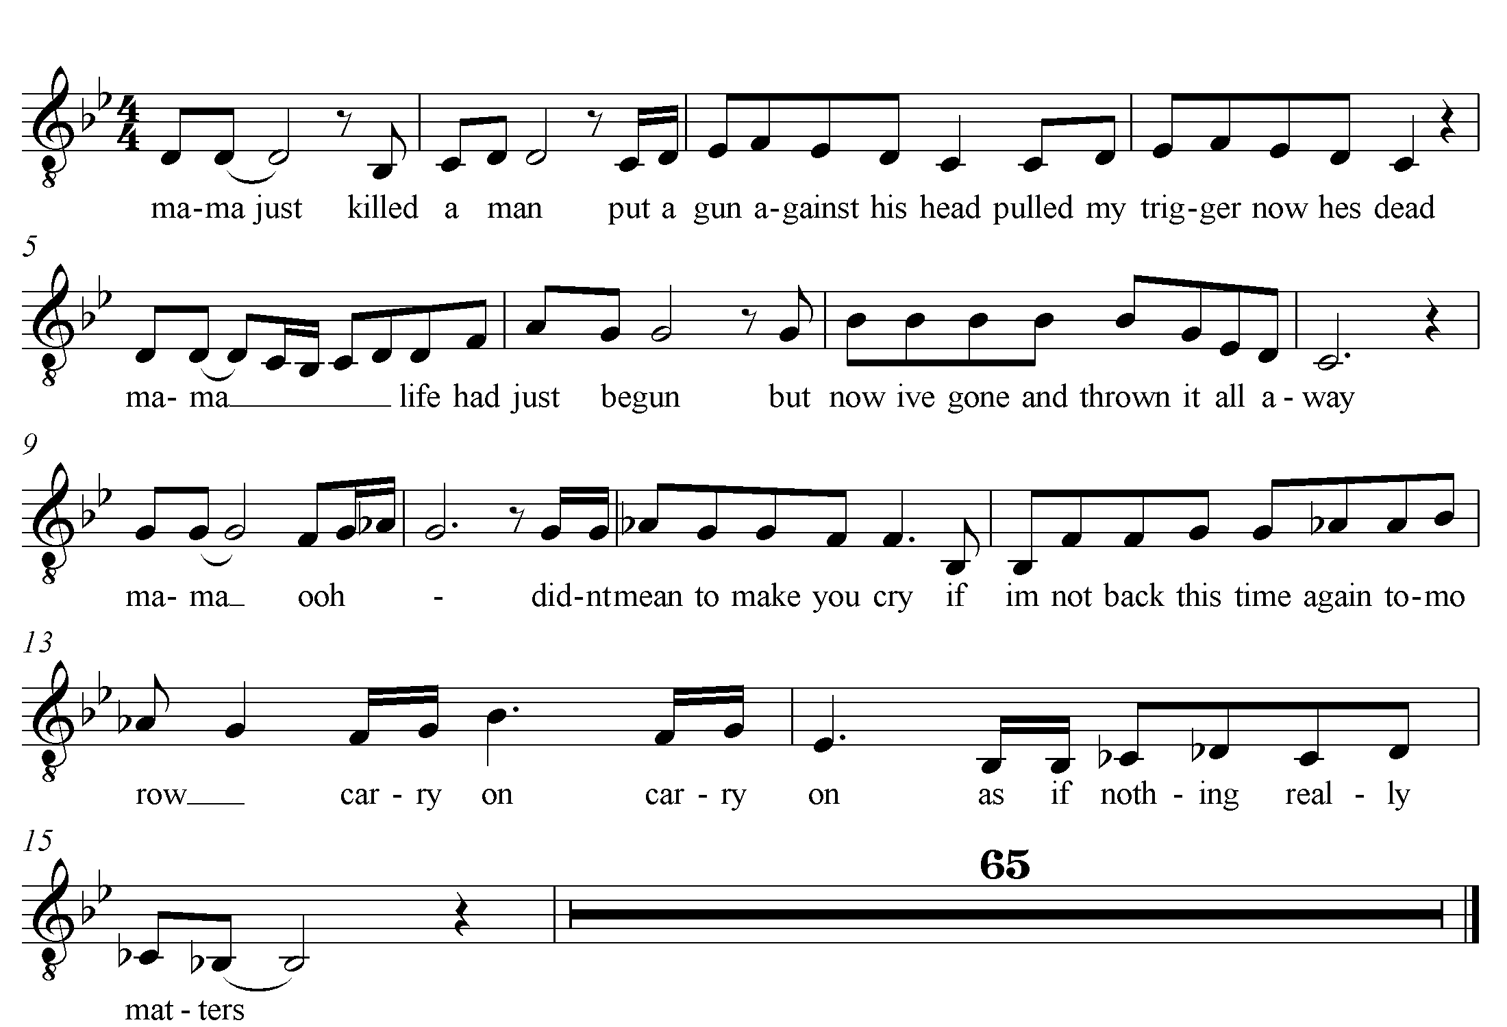
Verse 1 with the piano part added
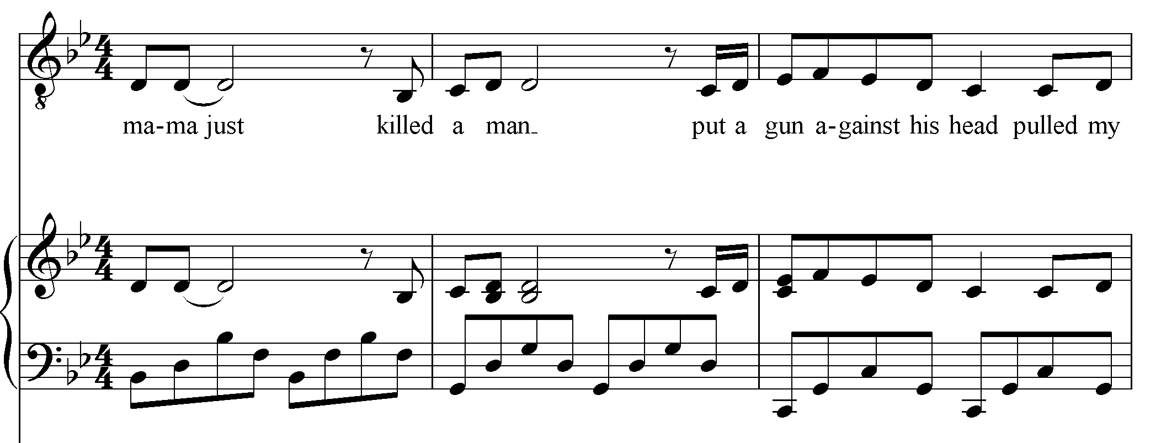

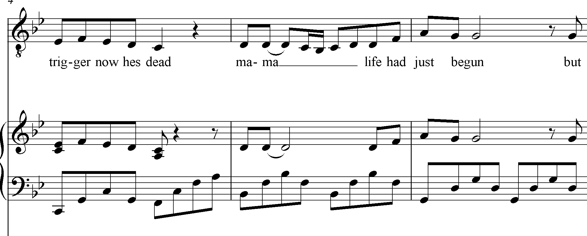

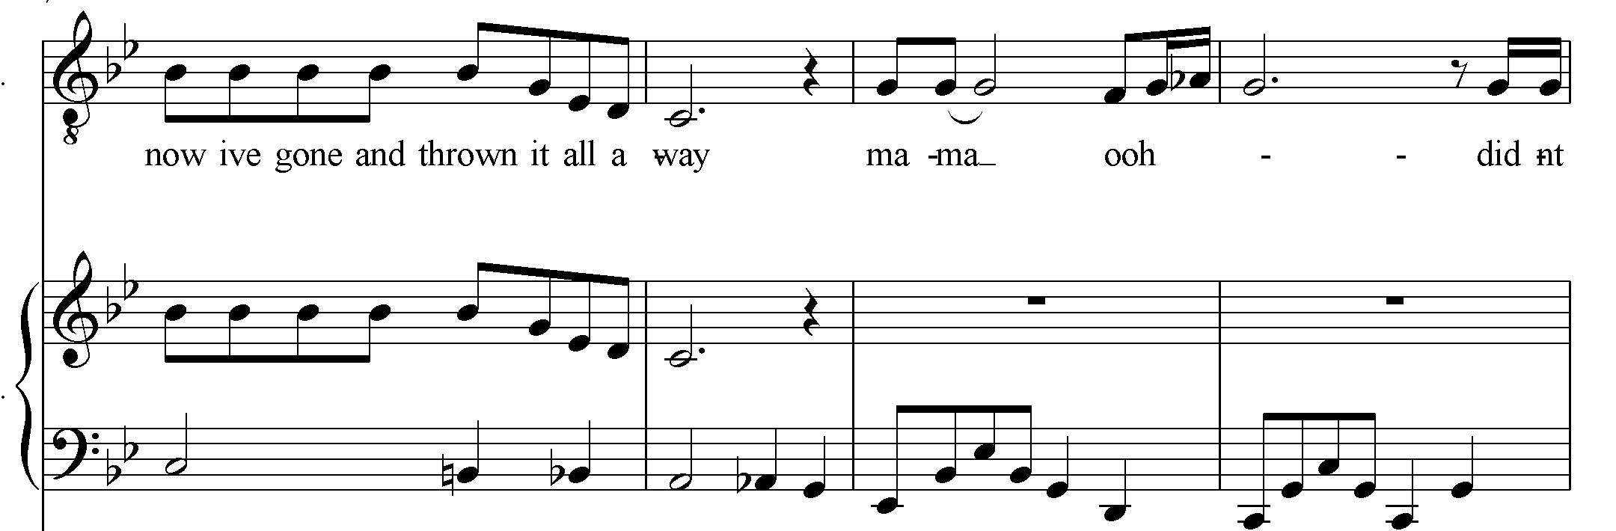

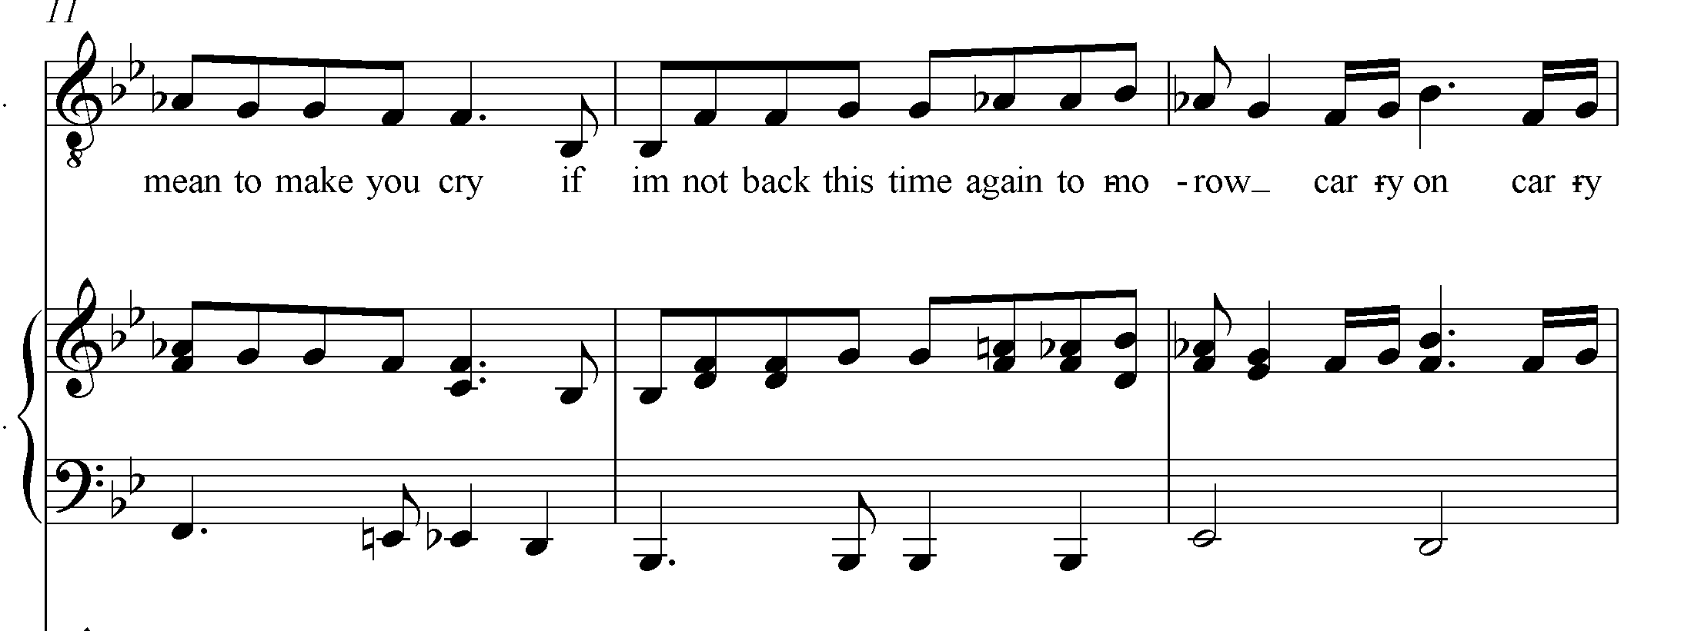
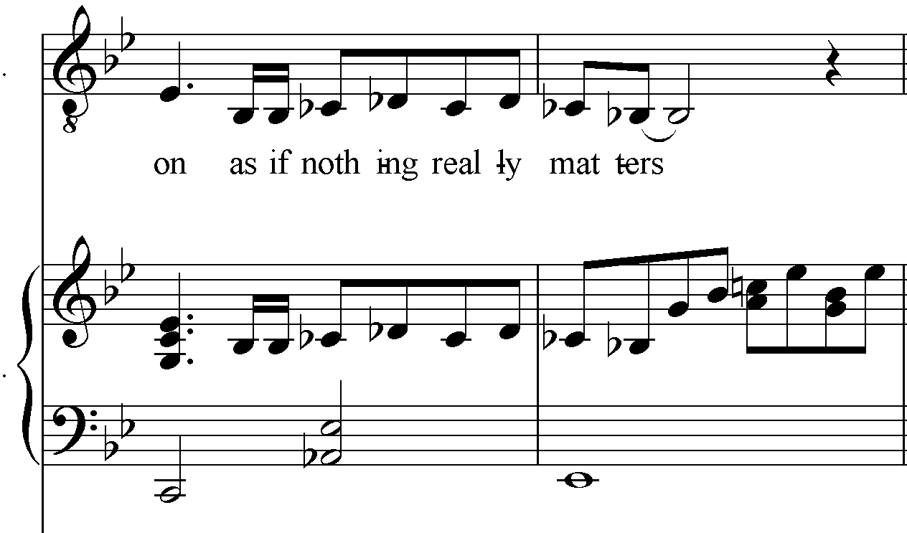
Verse 2 bars 34-46
LYRICS:
TOO LATE MY TIME HAS COME
SEND SHIVERS DOWN MY SPINE, BODYS ACHING ALL THE TIME
GOODYE EVERYBODY, I’VE GOT TO GO
GOTTA LEAVE YOU ALL BEHIND AND FACE THE TRUTH
MAMA, OOOH, (ANYWAY THE WIND BLOWS)
I DON’T WANNA DIE
I SOMETIMES WISH I’D NEVER BEEN BORN AT ALL
dj
FEATURES OF MUSIC IN THIS SECTION
- 13 bars of solo voice with backing vocals, piano, percussion and bass guitar. (Electric guitar joins in after 8 bars)
- It is a repeat of the music of verse 1
- The drums accompany from the start of verse 2
- There is wordpainting “sends shivers down my spine” with the use of a belltree
- The bass guitars are “overdubbed” in bar 42 as the electric guitar enters on the words “and face the truth”
- The music is moving from ballad style to rock
- Extra layers of backing vocals are added in bar 43 singing “ooh”
- Backing vocals sing a “countermelody” in bar 44 “any-way the wind blows” against the main vocal line
- The bass line is descending in bar 43
- There is a drum fill in bar 46

DESCRIBE ANY 3 DIFFERENCES BETWEEN VERSE 1 AND 2
- DRUMS COME IN AT BEGINNING OF VERSE 2 BUT NOT IN VERSE 1
- THERE ARE BACKING VOCALS IN VERSE 2 BUT NOT IN VERSE 1
- THERE IS A 4 BAR PIANO INTERLUDE IN VERSE 2 BUT ONLY A 2 BAR INTERLUDE IN VERSE 1
- WORDPAINTING IN VERSE 2 USES A BELL TREE COMPARED WITH CYMBALS IN VERSE 1
- THE MOOD IS TENSE AND ANGRY IN VERSE 2 WHILE ITS REGRETFUL IN VERSE 1

GUITAR INTERLUDE (BARS 47-54)
- HEAVY ROCK STYLE SECTION
- KEY IS E FLAT MAJOR
- LEAD GUITAR PLAYS GUITAR LICK (SOLO) BASED ON PENTATONIC SCALE (DOH-RE-ME-SO-LAH)
- SEMI-QUAVER SCALES AND TRIPLET RHYTHMS
- GLISSANDO IN BARS 47, 48 AND 54
- VIBRATO/BENDS IN 48, 50, 52 AND 53
- DESCENDING CHROMATIC LINE IN THE OVERDUBBED ACCOMPANYING GUITARS AND LEFT HAND AND BASS GUITAR (49, 53,54)
- POWERCHORDS IN GUITAR- DOUBLED ROOT AND 5TH ABOVE IT PLAYED IN BAR 50
- ENDS IN “A MAJOR”
OPERATIC SECTION (BARS 55-95)
- THERE IS AN ABRUPT CHANGE IN TEMPO AND STYLE
- KEY IS “A MAJOR”
- INSTRUMENTS: PIANO, LEAD GUITAR, BASS GUITAR, DRUMS, CYMBALS
- 2 BAR PIANO INTRO WITH STACCATO CHORDS ON EACH BEAT
- CHROMATIC PATTERN IN MELODY IN BARS 57 AND 58 (SIMILAR TO OPENING)
- WORDPAINTING IN BAR 61 “THUNDER BOLT AND LIGHTNING” WITH THE USE OF PERCUSSION
- FALSETTO VOICE IN 61-66
- STEREO PANNING IN 63-67
- ANTIPHONAL SINGING (MUSICAL CONVERSATION) IN BARS 63/64 (UNACCOMPANIED) ON THE WORDS “GA-LI-LE-O”
- BELL-LIKE ARRANGEMENT ON THE WORDS “MAGNIFI”CO”
- 6 BARS OF REPEATED MELODY “IM JUST A POOR BOY” WITH ACCOMPANIMENT-6 PART VOCALS
- PERCUSSION AND BASS GUITAR ENTER IN BAR 70
- 1 BAR PIANO LINK IN BAR 71
- BAR 77 = 10j BARS OF ALTERNATING SOLO AND VOCAL HARMONY “EASY COME EASY GO….BISMILLAH…NO WE WILL NOT LET YOU GO….LET HIM GO…”
- STEREO PANNING BAR 82-84 (WE WILL NOT LET YOU GO..”
- STABBING CHORDS IN BAR 86 AS INTENSITY RISES IN VOCALS, PIANO, GUITARS AND PERCUSSION
SCOND GUITAR INTERLUDE (BARS 96-99) THIS SECTION IS HARD ROCK
- KEY IS E FLAT MAJOR
- TIME SIGNATURE 12/8 (12 QUAVER BEATS PER BAR)
- 4 BAR INSTRUMENTAL SOLO ON LEAD GUITAR
- DISTORTION USED IN THESE 4 BARS
- GUITAR PLAYS A “LICK” WHICH IS A MELODIC DEVICE BASED ON A MUSICAL PATTERN
- BASS GUITARS (OVERDUBBED) AND DRUMS ACCOMPANY. NO PIANO
- SYNCOPATION BARS 96-99

SECOND SONG (BARS 100-122)
- SOLO VOICE FOR 14 BARS
- ACCOMPANIED BY LEAD, BASS GUITAR, DRUMS AND PIANO(AT END)
- SOLO VOICE SINGS MELODY WITH DESCENDING REPEATED NOTES AND SYNCOPATION (BARS 100-102)

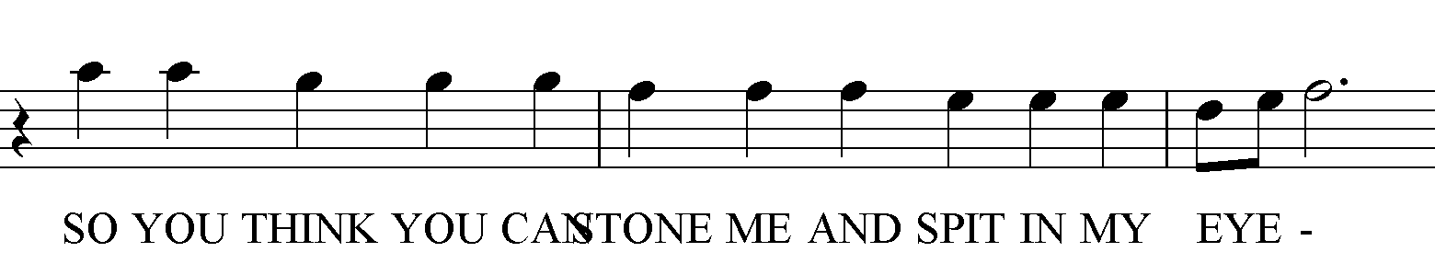
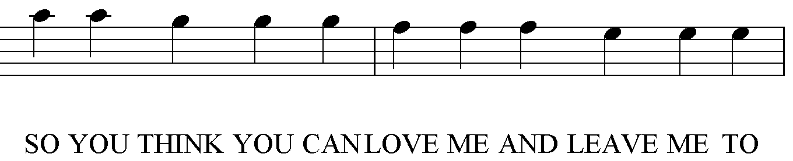

- THERE ARE ALSO “TRIPLET” RHYTHMS IN THE MELODY (3 CROTCHETS FOR THE PRICE OF 2)
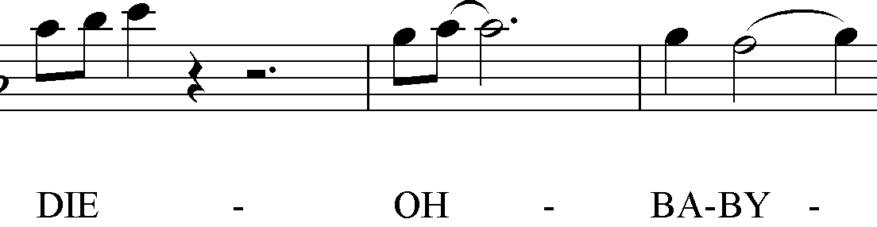

SYNCOPATION IN MELODY
`
- POWERCHORDS IN GUITARS THROUGH OUT THIS SECTION
- DISTORTION IN GUITARS ALSO
- CHANGE OF TIME SIGNATURE TO 2/4 IN BAR 103 AND KEY SIG TO D FLAT MAJOR. THE IDEA OF THIS IS TO JOLT THE LISTENER

BARS 113-122
- BAR 113 IS A BRIDGE PASSAGE FOR THE GUITAR WITH PERCUSSION
- IT FEATURES A RISING LICK WITH OVER DUBBING (BARS 117-120: THIS IS MISSING ON YOUR SCORES)
- STEREO PANNING IS USED HERE
- PIANO JOINS IN IN BAR 121 PLAYING OCTAVES
- MUSIC SLOWS BACK TO 4/4 AND TO BALLAD STYLE

RECAP AND CODA SECTION 123-138
- VOCAL HARMONY (SIMILAR TO BAR 43) WITH PERCUSSION
- OVERDUBBED GUITARS PLAYING RISING ARPEGGIOS (123-127)
- BARS 128 SOLO VOICE WITH PIANO AND BASS, PERCUSSION AND SOME LEAD GUITAR
- PERCUSSION DROPS OUT IN BAR 129
- MELANCHOLIC MELODY “NOTHING REALLY MATTERS….”
- PIANO PLAYS SIMPLE ACCOMPANIMENT SIMILAR TO VERSE 1
- LEAD GUITAR PANNED IN BAR 134-136
- MUSIC ENDS IN F MAJOR ON PIANO WITH GONG

